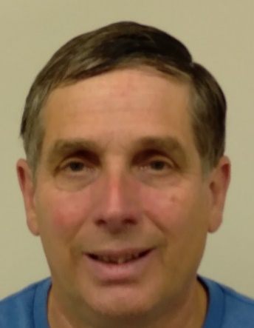**John Meistrell’s** natural curiosity and life long-trail of notable event coincidences, he calls “Markers,” has led him to a reconnection with childhood interests and realization of his intense passion for Data Science, statistics, math, music, and comedy. His family and relatives share similar talents and rich history.

He is related to the inventors of the Body Glove wet suit, [Bill and Bob Meistrell](https://images.app.goo.gl/pLPhQ54HVN7TQJqr7). Our common descendant “Nickolas Meistrell (born 1710) was a member of the [Brotherhood of St Sebastian](https://en.wikipedia.org/wiki/Saint_Sebastian).”[1] John’s children: Kristen graduated Deans List from Rutgers and writes grants at Audubon Society. Kimberly graduated *summa cum laude* from Maryland Institute College of Art and works for John Hopkins. Kayla is currently attending Hood College for a degree in Computer Science.

John shares the same natural curiosity and enthusiasm for science and understanding as [Alan Alda](https://www.worldsciencefestival.com/programs/alan-alda-and-the-art-of-communicating-science/) an advocate of science and education. Without knowing it, this life long curiosity, enthusiasm, and trail of “Markers” lead him to pursue a degree at Thomas Edison in Data Science, SAS, and Statistics. That trail started well before 9th grade.

In 9th grade, he was awarded the Outstanding Scholarship in Science by NJ Science Teachers Association for building an electric motor from dowel stick, bolts, wire, pencils, aluminum siding that was powered by a train set transformer and was showcased for over 10 years. He also ranked 16th in math in Union County NJ (a “Marker”). Math and the next 30 years as a computer programmer led him to SAS, Statistics and Thomas Edison University described later.

He was especially talented in the creation of applications and reports to summarize computer code and that made it understandable; There’s lots of bad code out there! He used the same to learn jQuery from the inside out. In 2019, he became interested in servers and Python that led him to an uncanny parallel to Guido van Rossum’s childhood.

John shared similar childhood obstacles and frustrations as the creator of Python language [Guido van Rossum](https://gvanrossum.github.io/bio.html) (a “Marker”). Author Rachel Keranen writes in [The Power of Python](https://books.google.com/books/about/The_Power_of_Python.html?id=vilmDwAAQBAJ): “**At 10, Guido** received an electronic kit from parents. In 5th grade, his first electronic blinking light model was a total dud - nobody cared or understood its importance. At 16, he graduated college." [2] **Also for** **John: At 10**, he built his first electronic bird at a class offered by Westinghouse in Clark NJ. In 9th grade the class laughed at the electronic motor he built until silence filled the room when it began to spin. At 16, he graduated high school. John realized the big difference was college. He was about to discover the subject that joined his life together.

In 2020 with everything closed due to COVID-19, John took a 60-mile bicycle ride to the end of LBI NJ and struck up a 15 minute once in a lifetime conversation with Mark the only other bicycle rider there (a “Marker”). John spoke of the obstacles to re-enter computer career without current experience and without a college degree. Mark, a 68 year old SAS programmer, strongly felt that only SAS certification and strong math would be needed to land a $60k job. John had finally discovered his passion and the reason for the life long-trail of “Markers”; A degree at Thomas Edison in Data Science, SAS, and Statistics.

John’s expectations are that Prior Learning Assessment (PLA) will provide the most effective way to learn how and to receive credit for his life experiences.

**Citations**

1. Van Voorhis - Meistrell, Rita (November 1983), The History of the Meistrell Family.
2. Keranen, Rachel (December 2017), Page 18, The Power of Python, ISBN 978-1502634153